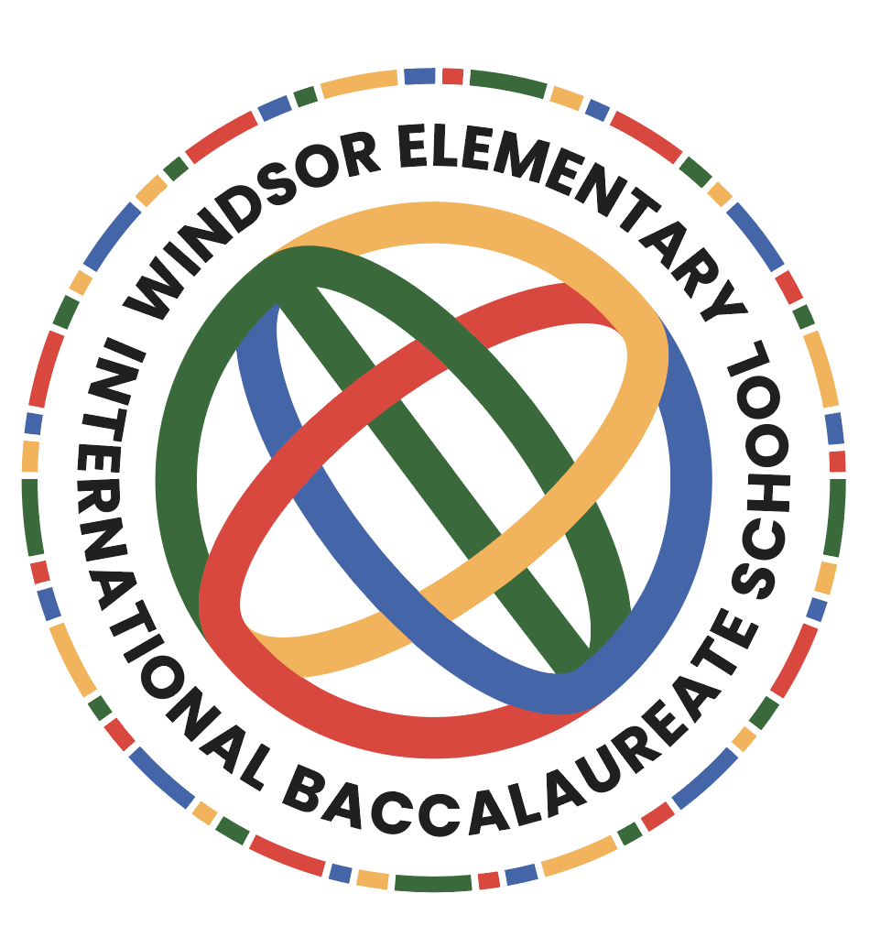

Windsor Elementary School
Language Policy

Philosophy
All teachers at Windsor Elementary school are language teachers. Academic and social language development occurs in all aspects of school. All International Baccalaureate students and teachers at Windsor are encouraged to embody the Learner Profile to become lifelong learners who realize that they have a role in creating a better and more peaceful world. In all classes, students read, speak, write, listen, create, and view authentic realia in a variety of ways and for a number of purposes. Utilizing the inquiry based approach of the IB curriculum frameworks across all academic and social subjects, students explore language and become effective and caring communicators in a multilingual world.

Language of Instruction
Windsor Elementary School uses English as its Language of Instruction. Through school-wide direct instruction, conversations, explorations, and investigations, students develop vocabulary, grammar, and syntax to increase their academic language fluency and literacy skills. As required by the state of South Carolina, all students in grades Kindergarten through Fifth receive daily literacy instruction as outlined in the South Carolina College and Career Readiness Standards.

Language of Instruction Expectations and Best Practices
Windsor Elementary is a caring language community that consciously enhances the language learning of all students. Our learning community continues to promote a language-rich campus for all students with a healthy balance of technology and multimedia resources, and balanced literacy.
Richland School District Two’s Learning Framework provides a model showing relationships among the essential components of the district’s student-centered, standards-based learning system. The Framework emphasizes the importance of each learner’s attaining the characteristics of a South Carolina Graduate, including collaboration, critical thinking, creativity and communication. This happens best when the strengths and needs of learners are identified and used to focus learning, teaching and assessment with the design of the context for learning.
Windsor Elementary School’s instructional model follows that of the district. The
teacher uses the gradual release of responsibility method of instruction. The teacher plans mini lessons, models, reads with, confers, assesses every student on a routine basis using formative data. Teachers and students provide feedback tied to the standards to fully engage students in the learning process.

Current practices relating to language teaching and learning follows the Balanced Literacy Model while meeting the needs of all students. This Standards-based instructional model includes, but is not limited to: Interactive read alouds, shared reading/writing, guided reading/writing, communication and speaking skills. To support spelling, referencing and bibliographic styles,teachers model and teach to the needs of each child within this framework.

Additional Language
Windsor Elementary implements the additional language instruction of Spanish to all learners at the school. Students are introduced to the basic elements of Spanish beginning in Kindergarten (age 5) and going through grade 5 (ages 10-11). Students learn vocabulary, greetings, and content knowledge in weekly Spanish classes.
Students whose native tongue is not English (the language of instruction) receive additional services through the English for Speakers of Other Languages program. These small groups are administered throughout the day in addition to collaboration with grade level and content teachers.

Mother Tongue Support
Windsor teachers support students whose mother tongue is other than English. We encourage parents to use and develop heritage language knowledge through reading and speaking. Teachers use Reading A-Z books in English and Spanish to develop literacy skills in both languages.
Official parent communications, including school newsletters, emails, and field trip forms are sent home in English and Spanish. The school library and the community lobby selections include titles that represent the home languages and cultures of our students. These include books about different countries and regions, and are available in a multitude of languages.

Review of the Language Policy
The faculty, staff, and stakeholders of Windsor Elementary will review this Language Policy on an annual basis.

References:
https://www.ibo.org/globalassets/ib-language-policy-en.pdf
https://www.ibo.org/language-policy/

