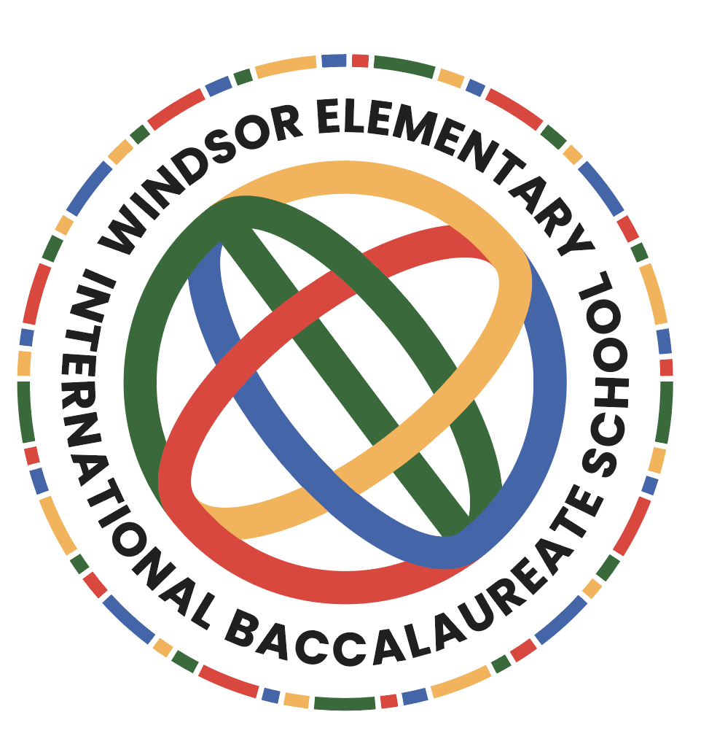

Windsor Elementary School
Assessment Policy

Philosophy
The main purpose of assessment at Windsor Elementary School is to support and encourage student learning. We believe that assessments and evaluations guide instruction. Assessment at Windsor involves teachers and students working together and being actively engaged in student progress. The PYP assessment process is designed for students to be engaged in the inquiry process and to integrate content areas when needed.

Purpose of Assessment
The purpose of assessment at Windsor Elementary is to inform students, parents, teachers and all other stakeholders in the process for student achievement.

- Students improve their knowledge base through the implementation of IB units of inquiry.
- Teachers develop a core understanding of curriculum development through IB unit development.
- Parents see evidence of student learning through projects, exhibition, and portfolios and also celebrate student learning with classroom visits and celebrations.

Types of Assessment
Pre and post test data is used to help teachers identify students’ strengths and weaknesses. Our district requires KRA (Kindergarten Readiness Assessment) for kindergarten, DRA (Developmental Reading Assessment) for grades kindergarten - second; MAP (Measures of Academic Progress) for grades second - fifth and Easy CBM (Curriculum Based Measures) for grades K-5th.
Formative assessments
Teachers use multiple formative assessments. Some include but are not limited to : Classwork, homework, exit tickets, IXL, graphic organizers, Kahoot, Think-Pair-Share, Fist to Five, and quizzes.

Formative assessments are designed to address all student learning needs and to move students to the next level. Content knowledge is assessed on a continuous basis and students are able to set personal learning goals with their IB units of inquiry.

Summative assessments
Teachers use a variety of summative assessments for student understanding. Summative assessments are used for gathering data in order to make instructional decisions. Some are but are not limited to: Mastery Connect benchmark testing, Exhibition projects, habitat projects (4th grade), classroom presentations, and Google doc writings to share.

The South Carolina State assessments are administered yearly. The SC READY (South Carolina College- and-Career-Ready Assessment) is given to students in grades 3-5 and assesses reading and math standards. The SC PASS (Palmetto Assessment of State Standards) assessment is also administered yearly, where fourth grade is assessed in science and fifth grade assessed in social studies.

Assessment of the Essential Elements of the PYP
The five essential elements of the PYP are assessed through units of of inquiry.
- Knowledge: Summative assessments are used to measure mastery of the central idea and lines of inquiry in each unit.
- Attitudes: Students self assess themselves and their process is recorded in portfolios.
- Transdisciplinary Skills (Approaches to Learning): Reflections on growth are recorded digitally on planners through Google docs.
- Key Concepts: Various concepts are developed throughout the IB units.
- Action: Student actions are recorded digitally on planners, and are notated in lesson plans

Assessment Practice
- Observations
- Pre and post tests
- Unit tests
- Quizzes
- Self reflections
- Open ended tasks
- Progress monitoring

School-wide Assessment Tools
- Project rubrics
- Writing rubrics (aligned with South Carolina State Writing Standards)
- Checklists

Assessment Review
As a faculty and staff, we will review our Assessment Policy annually.
References
PYP Playlist: Assessment

